**2014 EXECUTIVE BOARD**

President

**Ma. Luisa R. Madlangbayan**

Supreme Court of the Philippines

Tel. (632) 521-7223 ; 524-2706

Email: [luie.madla@gmail.com](mailto:luie.madla@gmail.com)

Vice-President

**Brinerdine G. Alejandrino**

U.S. Library of Congress, Manila

(632) 301-2917

Email: **brindal8@gmail.com**

Secretary

**Justin Harold A. Hingco**

Office of the President – PCDSPO

Malacañan Palace, Manila

(632) 735-9854

justin.hingco@pcdspo.gov.ph

Treasurer

**Edeliza C. Gallo**

Supreme Court Library

(632) 524-2706

Email: edelle_gallo@yahoo.com

Auditor

**Maria Cecilia I. Ayson**

Filipinas Heritage Library

(632) 759-8288 loc. 36

Email: ayson.mi@ayalafoundation.org

Public Relations Officer

**Randolf D. Mariano**

Thomas Jefferson Information Center, American Embassy

(632) 301-2561

Email: MarianoRD@state.gov

### Directors

**Eugene Jose T. Espinoza**

House of Representatives

(632) 951-3021

Email: [ejtespinoza@congress.gov.ph](mailto:ejtespinoza@congress.gov.ph)

**Huwaran Mapalarin-Sinag C. Galora**

STI Caloocan

(632) 294-4001

Email: mapalarin@gmail.com

**Alma Mila D. Prosperoso**

World Health Organization

Tel. (632) 5289038

Email: [almapros@gmail.com](mailto:almapros@gmail.com)

**Mercedita B. Servida**

Lopez Museum and Library,

Eugenio Lopez Foundation, Inc.

(632) 631-2425

Email: servida.mercy@yahoo.com

##### Ex-Officio

##### **Joseph M. Yap**

##### De La Salle University - Manila

##### (632) 536-0244

##### Email:[joseph.yap@dlsu.edu.ph](mailto:joseph.yap@dlsu.edu.ph)

##### Advisers

##### **Shirley Ingles-Cruz**

Commission on Appointments

Tel. (632) 834-2709

Email**:** [singlescruz@gmail.com](mailto:singlescruz@gmail.com)

**Alicia S. Paraiso**

Goethe-Institut Philippinen

(632) 817-8978

Email: [asap9523@yahoo.com](mailto:asap9523@yahoo.com)

**Milagros Santos-Ong**

Supreme Court Library

(632) 521-7223

Email: mso1951@yahoo.com



4th NATIONAL CONGRESS OF SPECIAL LIBRARIES OF THE PHILIPPINES

*Restructuring the Library: modern and contemporary techniques in redesigning libraries*

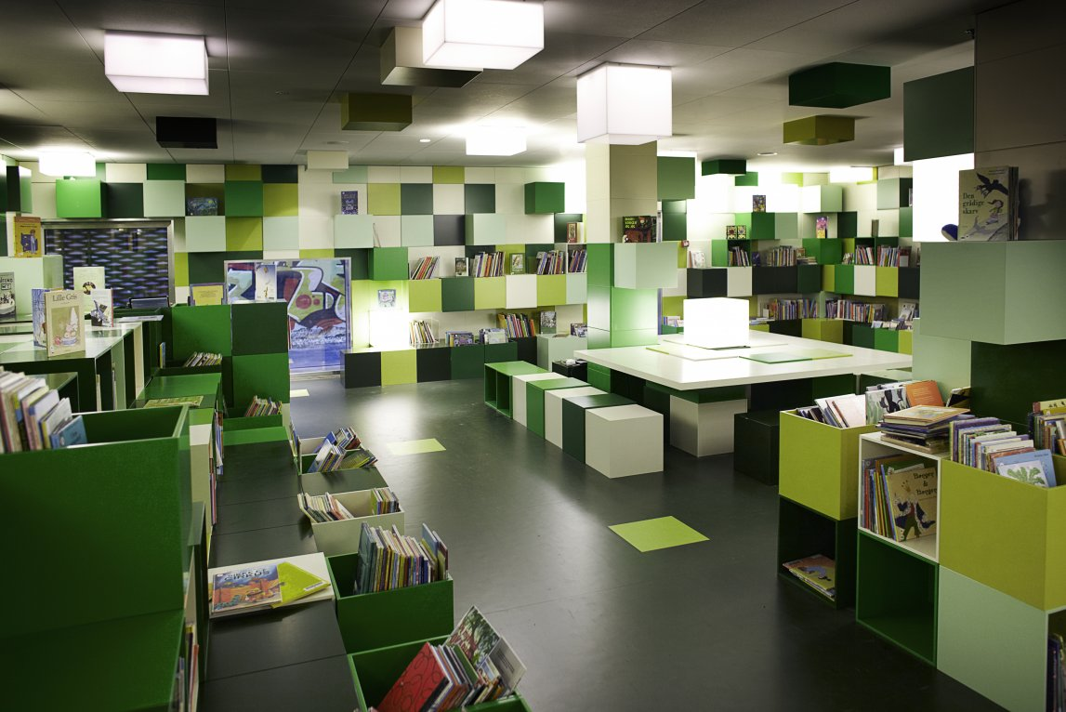

**October 22 – 24, 2014**

**Hotel Veniz, Baguio City**

**Day 1 October 22, 2014 (Wednesday)**

**1:00 – 1:30 p.m. Registration**

**1:30 – 2:00 p.m. Opening Ceremony**

**Doxology**

**National Anthem**

**Opening Remarks by**

**Ms. MA. LUISA MADLANGBAYAN President, ASLP**

**2:00 – 2:30 p.m. Keynote:**

**Hon. MAURICIO G. DOMOGAN**

**City Mayor, Baguio City**

**2:30 – 2:45 p.m. MECHANICS**

**Ms. BRINERDINE ALEJANDRINO**

**Vice President, ASLP**

**2:45 – 3:00 p.m. COFFEE BREAK**

**3:00 – 4:15 p.m. Usec. MANUEL L QUEZON III**

**PCDSPO**

**“Insight of library design for a library owner”**

**4:15 – 5:30 p.m. Ms. ANA MARIA B. FRESNIDO**

**Director of Libraries**

**De La Salle University**

**“Librarian’s perspective on library design: DLSU experience”**

**5:30 – 6:00 p.m. OPEN FORUM**

**7:00 p.m. DINNER**

**Justin Harold Hingco**

**Master of Ceremony**

**Day 2 October 23, 2014 (Thursday)**

**8:30 – 10:00 a.m. Mr. DHOBIE DE GUZMAN**

**ABS-CBN, Baguio City**

**“Green Library Project”**

**10:00 – 10:15 a.m. COFFEE BREAK**

**10:15 – 11:45 a.m. ARCHITECT/INTERIOR DESIGNER**

**“Expert’s insights on library design”**

**11:45 – 1:00 p.m. LUNCH BREAK**

**1:00 – 2:30 p.m. Dr. KLAUS ULRICH WERNER**

**Head, Philological Library of Free University of Berlin, Germany**

**Lecture on library design - 1st session**

**2:30 – 2:45 p.m. COFFEE BREAK**

**2:45 – 4:00 p.m. Dr. KLAUS ULRICH WERNER**

**Lecture on library design - 2nd session**

**4:00 – 4:30 p.m. OPEN FORUM**

**Alicia Paraiso**

**Master of Ceremony**

**Day 3 October 24, 2014 (Friday)**

**8:30 – 10:00 a.m. Dr. KLAUS ULRICH WERNER**

**Lecture on library design - 3rd session**

**10:10 – 10:15 a.m. COFFEE BREAK**

**10:15 – 11:45 a.m. Dr. KLAUS ULRICH WERNER**

**Lecture on library design - 4rd session**

**11:45 -12:00 p.m. CLOSING CEREMONY**

**Closing Remarks by**

**Ms. BRINERDINE ALEJANDRINO**

**Distribution of certificates**

**Randolf Mariano**

**Master of Ceremony**